Handouts for Paper One Compare and Contrast Table of Contents

Page 2: Paper One Compare and Contrast in MLA Format Instructions
Page 3: Paper One Rubric / Checklist
Page 4: Non-Western Country List, Preliminary Research Background, Advice for Wikipedia
Page 5: Beginning Formal Research
Page 6: Developing a Topic / Thesis
Page 7-8: Establishing Trustworthiness of a Source
Page 9: Developing a Thesis / Research Question
Page 10: Paragraph Structure
Page 11 – 13: Analysis / Evaluation Sample “Coca-Cola” / Note Sheet
Page 14 – 15: Analysis and Evaluation Student Samples
Page 16: MLA In-Text Citation Rules
Page 17: Purdue Owl
Page 18: Avoiding Plagiarism / Paraphrasing Techniques
Page 19: Paraphrasing Worksheet
Page 20: Paper Topic Worksheet / Outline
Page 21: How to Write an Introduction / Thesis – Argument Paper
Page 22: How to Write a Conclusion / Suggestions for Research Writing Paper One
Page 23 -24: MLA Guidelines for Paper Format / Basic Works Cited Instructions
Page 25 – 26: MLA Sample Paper
Page 27: MLA Sample Works Cited
Page 28 – 30: Aristotelian Appeals: Logos, Ethos, Pathos / Types of Evidence
Page 31: Examples of Strong Introductions
Page 32: Strong Introductions Continued
Page 33 – 34: Paper Two Argument Based on a News Video / Format / Country List
Page 35: Beginning Research Reminders
Page 36: Argument Paper Rubric
Page 37: Argument Paper Outline
Page 38 – 39: Recognizing and Avoiding Logical Fallacies

Paper One Compare and Contrast in MLA Format

Genre: The first essay will be a compare and contrast style essay on a topic of interest from a non-western country. A comparison shows how two things are alike. A contrast shows how two things are different. In this case, the topic will need to be examined from an American perspective *AND* from a perspective of another country. Most importantly, you will need to draw conclusions from the findings.
Learning Objective: This first essay needs to show a command of the topic studied. This means that you will need to have a good working understanding of the culture / country concerning this topic. Of course, this is limited by only having 4-5 weeks to write the paper; however, working knowledge on the topic should be able to be gained with reading 10-12 academic articles. At that point, you will have more information on that given topic than nearly any one else on campus. Because of this working knowledge, you should be able to form judgments based in these findings.
Important: The essay should not be a high school style report. We will discuss the differences between high school reports and college research papers and a large portion of the grade will be on fulfilling the requirements of a college level research paper (mainly using analysis, evaluation, and reaching conclusions, while avoiding plagiarism).

Recommendations: 1. Because of length of paper, avoid history / historical topics. The topic should be focused in the present / near present. Assume that your reader has a working knowledge of the subject. 2. Because of the length of the paper, avoid long / block quotations. Quotations should be no more than 2-3 lines of text. If the quotation is longer than that, consider paraphrasing. Or, as a last resort, extend the length of the paper to make up for the lengthy quotation. 3. Paragraphs should be approximately ½ of a double spaced page. If paragraph is longer, separate into two paragraphs.

Basic guidelines for paper: 5 complete double spaced pages long AND a works cited (10 % deduction for each half of page short. Not accepted under 4 full pages.)

In black, 12 point, Times New Roman font (take note – this is not the default font)

Standard Microsoft Word margins (1 inch on bottom and top and 1 inch on sides)

Standard double-spacing (check this under the layout /spacing tab. (It should say 0 before and 0 after).
Written in MLA Style: See Purdue Owl website for style help

Minimum of 7 sources – at least 5 academic journals and 2 other trustworthy sources. (10 % deduction for each missing source. At least 75% of paper needs to be based on academic journals. The paper will not be accepted without at least 2 academic journals.) Please remember that Wikipedia cannot be used in the final paper.
All work must be submitted electronically via course management system.
The essays will be examined using plagiarism software
I return papers in the order I receive them, so turn your papers in early when possible.

Rubric / Checklist for Paper One

Format (10 %):
Heading according to MLA format / Purdue Owl
Last name and page number at the top right corner of each page / Creative Title
Times New Roman 12 pt. font / Double spaced without extra spaces
*Check paragraph spacing (Before 0 pt, After 0 pt)* / Indent each new paragraph
Check Margins (1” top and bottom, 1” left and right)
Length – minimum of five full pages and a Works Cited

Introduction (5%):
Introduce the topic / Create interest
Provide necessary (but limited) background information / Preview the rest of the essay.
Thesis at end of paragraph / Thesis is defendable and reasonable
Paragraphs are approximately ½ of a double spaced page
Balanced proofs (logos / logic, pathos / emotion, ethos / authorial credibility)

Thesis (5 %):
Narrow in scope (A book could not be written on topic) / Specific
Clear position / Clear comparison and contrast with American Culture
Not merely an announcement / statement of fact

Body (25 %):
2 - 3 sub-topics / Supporting Statements
Each sub-topic has at least two pieces of evidence for compare and two for contrast
Each piece of evidence is analyzed (break it down – Why is it important? What does it mean?) and evaluated (How does it connect to the larger subject?)
Paragraphs should be approximately ½ of a double spaced page
Last line in each paragraph clearly connects back to thesis

Citation (10 %):
Author Page # format (Dories 15). / If there is no author, then use title in “quotes”
If not an academic journal, then check source for trustworthiness
Seven Trustworthy Sources / At least five academic journals
Every sentence that is not common knowledge (25 % of classmates would know) needs a citation.

Works Cited (10 %):
Title is normal size and font (12 pt Times New Roman) not italicized or bold
All entries are alphabetical / Double spaced with no extra spaces
Each entry has a hanging indent
If using a works cited generator, check for ALL CAPS and make sure that italics are used properly
Check it against a sample works cited and look for missing information

Conclusion (5 %):
Restate the topic, main points, and why it is important / Restate the thesis idea / Call for action (if applicable)

Voice / Style (10%):
Proofread for grammar, punctuation, and spelling (read out loud) / Avoid repetition
Check the first sentence of each paragraph for unclear pronouns (they, them, he, she, etc.)
Check for ethos (Remove I, we, us, me, you and phrases like “in my opinion”, “I think”)

Other (20 %):
Extended from other categories
Missing academic journals (- 10% per journal missing / Paper not accepted without 2 academic sources)
Short of five full pages (- 10% per ½ page short / Paper not accepted under 4 pages)
Country List for Research

Southern Asia: Vietnam, Laos, Cambodia, Philippines, Thailand, Malaysia, Indonesia, etc.
Northern Asia: China, Japan, Taiwan, North Korea, South Korea, Kazakhstan, Russia, etc.

The Middle East: Israel, Palestinian Territories, Iraq, Iran, Jordan, Qatar, Saudi Arabia, Syria, Yemen, Oman, United Arab Emirates, Kuwait, etc.

India / Pakistan Region: India, Pakistan, Nepal, Bhutan, Bangladesh, Burma, etc.

Africa: Tunisia, Algeria, Morocco, Libya, Chad, Niger, Mali, Eritrea, Nigeria, Ghana, Ethiopia, South Africa, Botswana, Namibia, Zimbabwe, Congo, Kenya, Somalia, Tanzania, Uganda, etc.

Preliminary Research: Background

The goal of preliminary research is to get a basic understanding of the topic, find effective key words, and it may lead to trustworthy sources.
Useful resources for background information:
Textbooks, Dictionaries, Encyclopedias, Wikipedia, News Articles, Article databases
Preliminary Research: Keywords

Keywords are important words/concepts found in your research question or thesis.
A quick and dirty way to pull keywords from a research question/thesis is to choose the most important nouns. Using keywords to search will always retrieve more results than phrases or sentences.
Find keywords:
In encyclopedias (wiki), news articles
In bibliographies found at the end of books and articles
In a thesaurus
Dr. Dories / librarian
Advice for searching on Wikipedia
1. Start with a broad search term, then narrow as you read.

2. Use the Table of Contents to find subjects

3. Use links to expand search.

4. Look for “main article” link for more information

5. Use citations to find original work

6. List Key words to help with future research

**Important – Wikipedia cannot be used as a source in the paper**

Beginning Formal Research

1. Always begin by brainstorming key words - the more the better. If you do not start with effective key words, it will impact the articles you are able to find, the draft you are able to write, and is the biggest problem that prevents students from turning in a solid final copy.
2. Begin preliminary research. Use Google, Google news, Wikipedia (cannot be used in final papers), etc. The goal of preliminary research is to get a basic understanding of your topic, find effective search words, and possibly some leads towards formal sources.

3. After reading articles, brainstorming key words, and doing preliminary research, then move on to the library databases.

4. Recommended search (there are other search possibilities, but this is how I recommend starting): Click on “Databases”, “E”, then “Ebsco Host” and “Connect to this Database”. Begin inserting key words.
5. In the first box, start with a broad term – usually the name of the country. In the second box, use a middle term – usually the broad topic. Check how many results you get with these terms. If you get a large number of results (1000s or more), then insert a third narrow term to your search.

6. If you still get a lot of results, then consider narrowing using a different method. After you search, on the left hand side, change the publication date to the last ten years, click full text, and scholarly journals. There are other limiters as well.

7. If you are getting too many results that do not match your topic, consider using the word “NOT” in your search. For example, if you were to search “Japanese” AND “Sushi”, and you were to get too many results from American chefs about making sushi, you could enter “Japanese” AND “Sushi” NOT “America”.
8. After finding an article on your topic, click on the entry and look at “subject terms” for more search terms to expand your search. If the article is useful, use the icons on the right to e-mail it to yourself, print, or click on “cite” and “MLA” to get the citation information.

9. If you find an article that is useful, read their Works Cited page to see if any of the articles they cited might be useful for your paper. If so, put the author or title into a new search.

10. If you are getting too few results, then change databases.

11. Most importantly, if you are struggling with your search, seek help from me during class workshops, during my office hours, go to the Tutoring Center, or seek help from the librarians. An important part of any research course is learning to use the resources that the University provides – including people. The Purdue Owl Website may be helpful as well.

Developing a Topic

The first essay will be a compare and contrast style essay on a topic of interest from a non-western country (see Country List handout). A comparison shows how two things are alike. A contrast shows how two things are different. In this case, the topic will need to be examined from an American perspective and then from a perspective of another country. Most importantly, you will need to draw conclusions from your findings.

Choosing a Topic: When choosing a topic, be sure not to choose two unrelated subjects. The subjects must have some basic similarities. For instance, it would be reasonable to choose to compare/contrast music of two different countries, the food or travel, politics, education systems, but it would not be reasonable to compare American music and the state of Iraqi refugees.
Narrow Topic in Research Process: Pick a topic that you find interesting, so that the paper will be easier write. Some examples of general topics (that will need to be narrowed in the research process):

1. Education 2. Health Care 3. Sports 4. Music / Art 5. Environment 6. Family roles 7. Technology 8. Military 9. Religion 10. Educational Major 11. Hobby 12. Humor / Comedy

After choosing a few general topics, begin formal research. It is important that to have a couple ideas in mind in case you decide to change topics. After some research, begin narrowing the topic. Here are some examples:

1. Art education on the secondary level in the US and Japan 2. Similarities and Differences in Family Life in the US and Thailand 3. Environmental Conservation in Malaysia and the US

*Important* – In most cases, the topic will need to be narrowed even further as the writing process begins.

Make sure that the topics compared are reasonable – for instance, “Who has the stronger military: the US or Thailand?” would not be a reasonable topic because the US military is vastly larger and spends more than most of the world combined. However, this topic could be adjusted to be more reasonable with a minor change: “What could the US Military Learn from Thailand and What could the Thai Millitary Learn from the US?”
Developing a Thesis

The thesis statement will evolve somewhere in the process from brainstorming to note taking. Sometimes the thesis will not come until late in the process, but this can create some challenges. First make a list of similarities and differences. Then, begin asking questions: Is there something important, significant, or interesting in the similarities and differences on my list? After doing significant research, make an assertive declarative sentence that sums up your view. For example: “The United States needs to adopt policies on environmental conservation closer to those that Malaysia has in place because …” This sentence can be adjusted as needed.

Establishing Trustworthiness of a Source

Final Paper Requirements: A total of seven trustworthy sources are required. Five of the sources need to be academic journals. The other two can be journals or other trustworthy sources. If not an academic journal, trustworthiness needs to be evaluated. (75% of paper needs to come from academic journals).

Evaluating Sources:

1. Evaluate format: *Academic journals are the most trustworthy.*
American government websites, well known American government organizations (CDC, Census, etc.), well known scientific organizations, well known medical organizations are highly trustworthy.
Books from trustworthy sources, well respected news sources (newspaper, web site, periodicals, etc.), foreign government data are medium level of trust. Find out who is writing – are they an expert in their field with a terminal degree (PhD, etc.)?
Web sites, blogs, news sources that are less well known, news sources with clear political slant, lesser known periodicals, etc. are low level of trust. Find out who is writing – are they an expert in their field with a terminal degree (PhD, etc.)?
2. Evaluate date written - For our purposes, sources need to be from the last 10 years. In scientific or medical fields, it is usually 5 years.

3. Evaluate for Bias – Bias is a prejudice in favor of or against one thing, person, or group compared with another, usually in a way considered to be unfair. This occurs in regards to race, age, ethnicity, experience, gender, location, class / income, occupation, politics, or religion. All people have biases; so, it is important to be aware that sources may have these biases as well. Peer review is one effective method for reducing bias. Look for phrases like “In my opinion”, “I think”, and “I believe” for bias. Also, look for extreme opinions, hyperbole, and exaggeration.
4. Identify purpose, tone, and supporting evidence. Another way to look for potential bias is to identify the author’s purpose, tone, and supporting evidence. Look for the author’s purpose or reason for writing. Is the author writing to inform or persuade? If the author is claiming that their purpose is to inform, yet most of the article is focused on persuasion, then the source might be less trustworthy. This would mean they have a hidden motive or agenda.

Identifying purpose also helps the reader evaluate for conflict of interests. For example, an organization like PETA might post articles on their web-site that are critical of the meat industry because it matches their agenda of convincing people to consume less meat. Therefore, any article from this source should be viewed skeptically and evaluated for trustworthiness. Does the author have a personal stake in the issue? Who is funding the study?

Another way to look for bias is through identifying tone. Does the author sound positive, negative, or neutral about the subject? If an article refers to a priest as a visionary (positive tone) or an extremist (negative tone), then it can act as a signal post for potential bias. In most academic writing, the author should attempt to have a neutral tone.

5. Using exclusive language about race, ethnicity, gender, sexuality, class, or similar identifiers can also signal bias. For example, if in an article, a driver is identified as a certain gender or ethnicity, ask is it necessary to understand the subject? If not, then it may be using exclusive language based in stereotypes that indicates bias.

6. Use a variety of different forms of evidence - One of the most important methods for identifying bias is to examine the evidence that an author uses or chooses not to use. If you are unsure about evidence that an author uses, then find another source and double check that evidence. If an author uses evidence from biased sources, then the article is probably untrustworthy. If an author decides not to include evidence that would be useful, then it may be untrustworthy. The most trustworthy articles reference data, expert testimony, and various other forms of evidence from trustworthy sources.

7. Evaluate Professional Affiliation – This is the most important step for determining trustworthiness. Check to see if the person has a terminal degree in their field (PhD or equivalent). Do they have decades of experience? Are they associated with a university? Make sure that their degree is in the field they are writing about. In most cases, a quick Google search will help determine their expertise.

Cite, Cite, Cite: Every sentence that is not common knowledge (25 percent of your class mates would know it) needs to be cited. If it appears that there are too many citations, then it most likely means that there needs to be more analysis and evaluation.

Developing a Thesis / Research Question

Research Question / Thesis: The thesis statement will evolve somewhere in the process of note taking. Sometimes the thesis will not come until late in the process, but this can create some challenges.

1. Begin by asking questions: Once you have selected an initial topic, the next step is to develop research questions. You'll do this by using probing questions, such as what, why, when, how, would/could, should. Phrasing your topic in the form of questions helps direct the research process.

What questions focus on a particular aspect of the topic. What is the main reason why most marriages are arranged in India?

Why questions ask for an explanation of something--why something happened, why it did not happen, or why one thing is better than another. Why are arranged marriages popular in India, but not in the US?

When questions focus on timing or history. When did arranged marriages become dominant in India? When did marriage through choice become popular in the US? [Be careful here: Historical topics are not recommended in a five page paper, but it can help you understand the context.]

Where questions focus the topic on a location, either geographical or other. Where, in India, are love marriages most popular? Least popular? US?
How questions focus on aspects of the topic, on a process, or on the origin. How do the rituals in arranged / love marriages indicate what each culture values?
Would / Could questions focus on possibilities. Would arranged marriages be more popular in the US if they were explained more in popular culture?

Should questions focus on the appropriateness of a particular action, policy, procedure, or decision. Should the government be involved in marriage?
2. Formal research: As you research, take detailed notes being careful to put quotations around any exact wording. For each source, write down the page number and make sure to write down enough information to retrieve that source later in the process. It is highly recommended to copy and paste information from database as instructed in class.

3. Brainstorm: After taking notes on a number of articles, begin making a list of similarities and differences on the topic. Then, begin asking questions: Is there something important, significant, or interesting in the similarities and differences on my list? After doing significant research, make an assertive declarative sentence that sums up your view.
Example: “The United States needs to adopt policies on environmental conservation closer to those that Malaysia has in place because …” This sentence can be adjusted as needed.
A good research question will lead to a thesis statement.

For example, the question... What is the impact of robotics in the classroom in Japan and the US? Might lead to the following thesis:

Compared to the United States, Japan is more dedicated to the development of robots that can be of assistance in the classroom. Many studies have shown that children welcome robots; they can improve educational outcomes, and assist overworked teachers (Langley 357). This illustrates that the United States should embrace the Japanese perspective on robotic technology in the classroom in order to improve their struggling education system.
Qualities of a strong thesis statement: 1. Answers a question 2. Is engaging 3. It can be challenged or opposed, thus also defended 4. Is supported by the paper 5. Is neither too broad nor too vague

Paragraph Structure

From Report to Research Paper

Evidence: Data or individual fact on which to base proof or to establish truth or falsehood. This is usually a quotation, paraphrase, or statistic from a trustworthy source. (Add clause before)
Analysis: The separation of an intellectual or material whole into its constituent parts for individual study. (Breaking it down / what does it mean? Why is it important?)
Evaluation: To examine carefully – (bigger picture – How does it connect to the larger idea?)

Paragraph Structure – In most cases, keep 1-5 listed below to 1-2 sentences each
One: Introduction to idea being discussed - General statement that does not need to be cited

Two: Evidence (*remember to add intro clause) – Quote, Paraphrase, or Statistic

Three: Analyze Evidence (Break it down - What does it mean? Why is it important?)

Four: Evaluate Evidence (How does this connect to the larger subject?)

Five: Connect back to thesis (Maintaining the thesis)

Analysis / Evaluation Steps:

1. In evidence sentence, circle the important nouns or most important parts overall.
2. Begin asking Analysis / Evaluation questions, as listed above
3. Freewrite based on those questions
4. Formalize that writing for the paper draft (keep paragraphs to ½ a double spaced page)

Example

When writing the body of a research paper, it is important to use a general sentence that does not need a citation to introduce the research. One important rule of in-text citation is to “use the author’s name and page number after the quote” (Dories 7). After a quote or paraphrase, use a few sentences analyzing the information (breaking it down), evaluating it (the bigger picture), and connecting it back to the thesis. Throughout this process, avoid phrases like “in my opinion” or “I believe” as it weakens the authorial ethos. Instead, use the information provided to make reasonable judgments as fact. An important aspect of the information above is that for any quote in the entire paper, there must be a clause introducing or concluding the sentence.

Analysis / Evaluation Sample “Coca-Cola” / Note Sheet
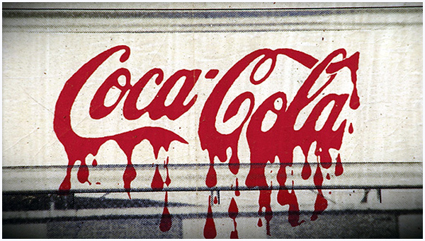
Working Thesis: The Labor policies of Coca-Cola in India are barbaric in comparison to their policies in the United States. Both Indians and Americans should use every possible measure to force Coca-Cola to be a more socially responsible company.

Sub-Topic One: Coca-Cola is Polluting Ground Water [Contrast]
1. (India) - Coca Cola has been taking groundwater from areas that desperately needed the water to survive throughout India.
2. (U.S.) The US has much stronger regulations regarding use of ground water.

Evidence Sub-Topic One: [Circle important parts, then explain to reader why they are important]
1. In 2006, Coca-Cola opened a factory in Kerala, India. The company has since been taking the groundwater from under the feet of the villagers, who are landless laborers (Smith 47). The only water these villagers have access to is water that is used to cremate the people that die in their village (49).

Analysis: Why is this important? Break it down and explain to the reader.
Evaluation: What is the bigger picture here? How does it connect to overall subject / thesis?

2. In the Kala Dera section of Rajasthan, where there is also a Coke factory, ground water levels have been documented dropping at an alarming rate and high levels of contamination have been found (Hyams 35).

Analysis: Why is this important? Break it down and explain to the reader.
Evaluation: What is the bigger picture here? How does it connect to overall study?

3. In another section of India located close to a Coke factory, villagers reported bouts of dizziness, and some developed rashes after bathing in the undoubtedly contaminated water (Frank 132).

Analysis: Why is this important? Break it down and explain to the reader.
Evaluation: What is the bigger picture here? How does it connect to overall study?

Analysis (break down): Why is groundwater important? Why is it important that they are landless laborers? Cremation water? Contamination? Dizziness? Rashes?
Evaluation (bigger picture): Write about what it would mean to a person / community to not have clean drinking water. Connect to thesis – India’s labor policies need to be changed
Student Freewrite Example: Water, as we’re all well-aware, is one of the most basic human necessities. Without water, the body will cease to function in an alarmingly short amount of time. But when faced with the choice between contaminated water and no water at all, how does one make such a choice? Both options result in equally horrific possible deaths. Moreover, what right does Coca-Cola have to force this choice upon the people of these villages?
As you can see – all of the previous sentences do not come from sources; instead, they come from evaluation. However, they are developed based on the research. Make sure to formalize language for final copy of paper.

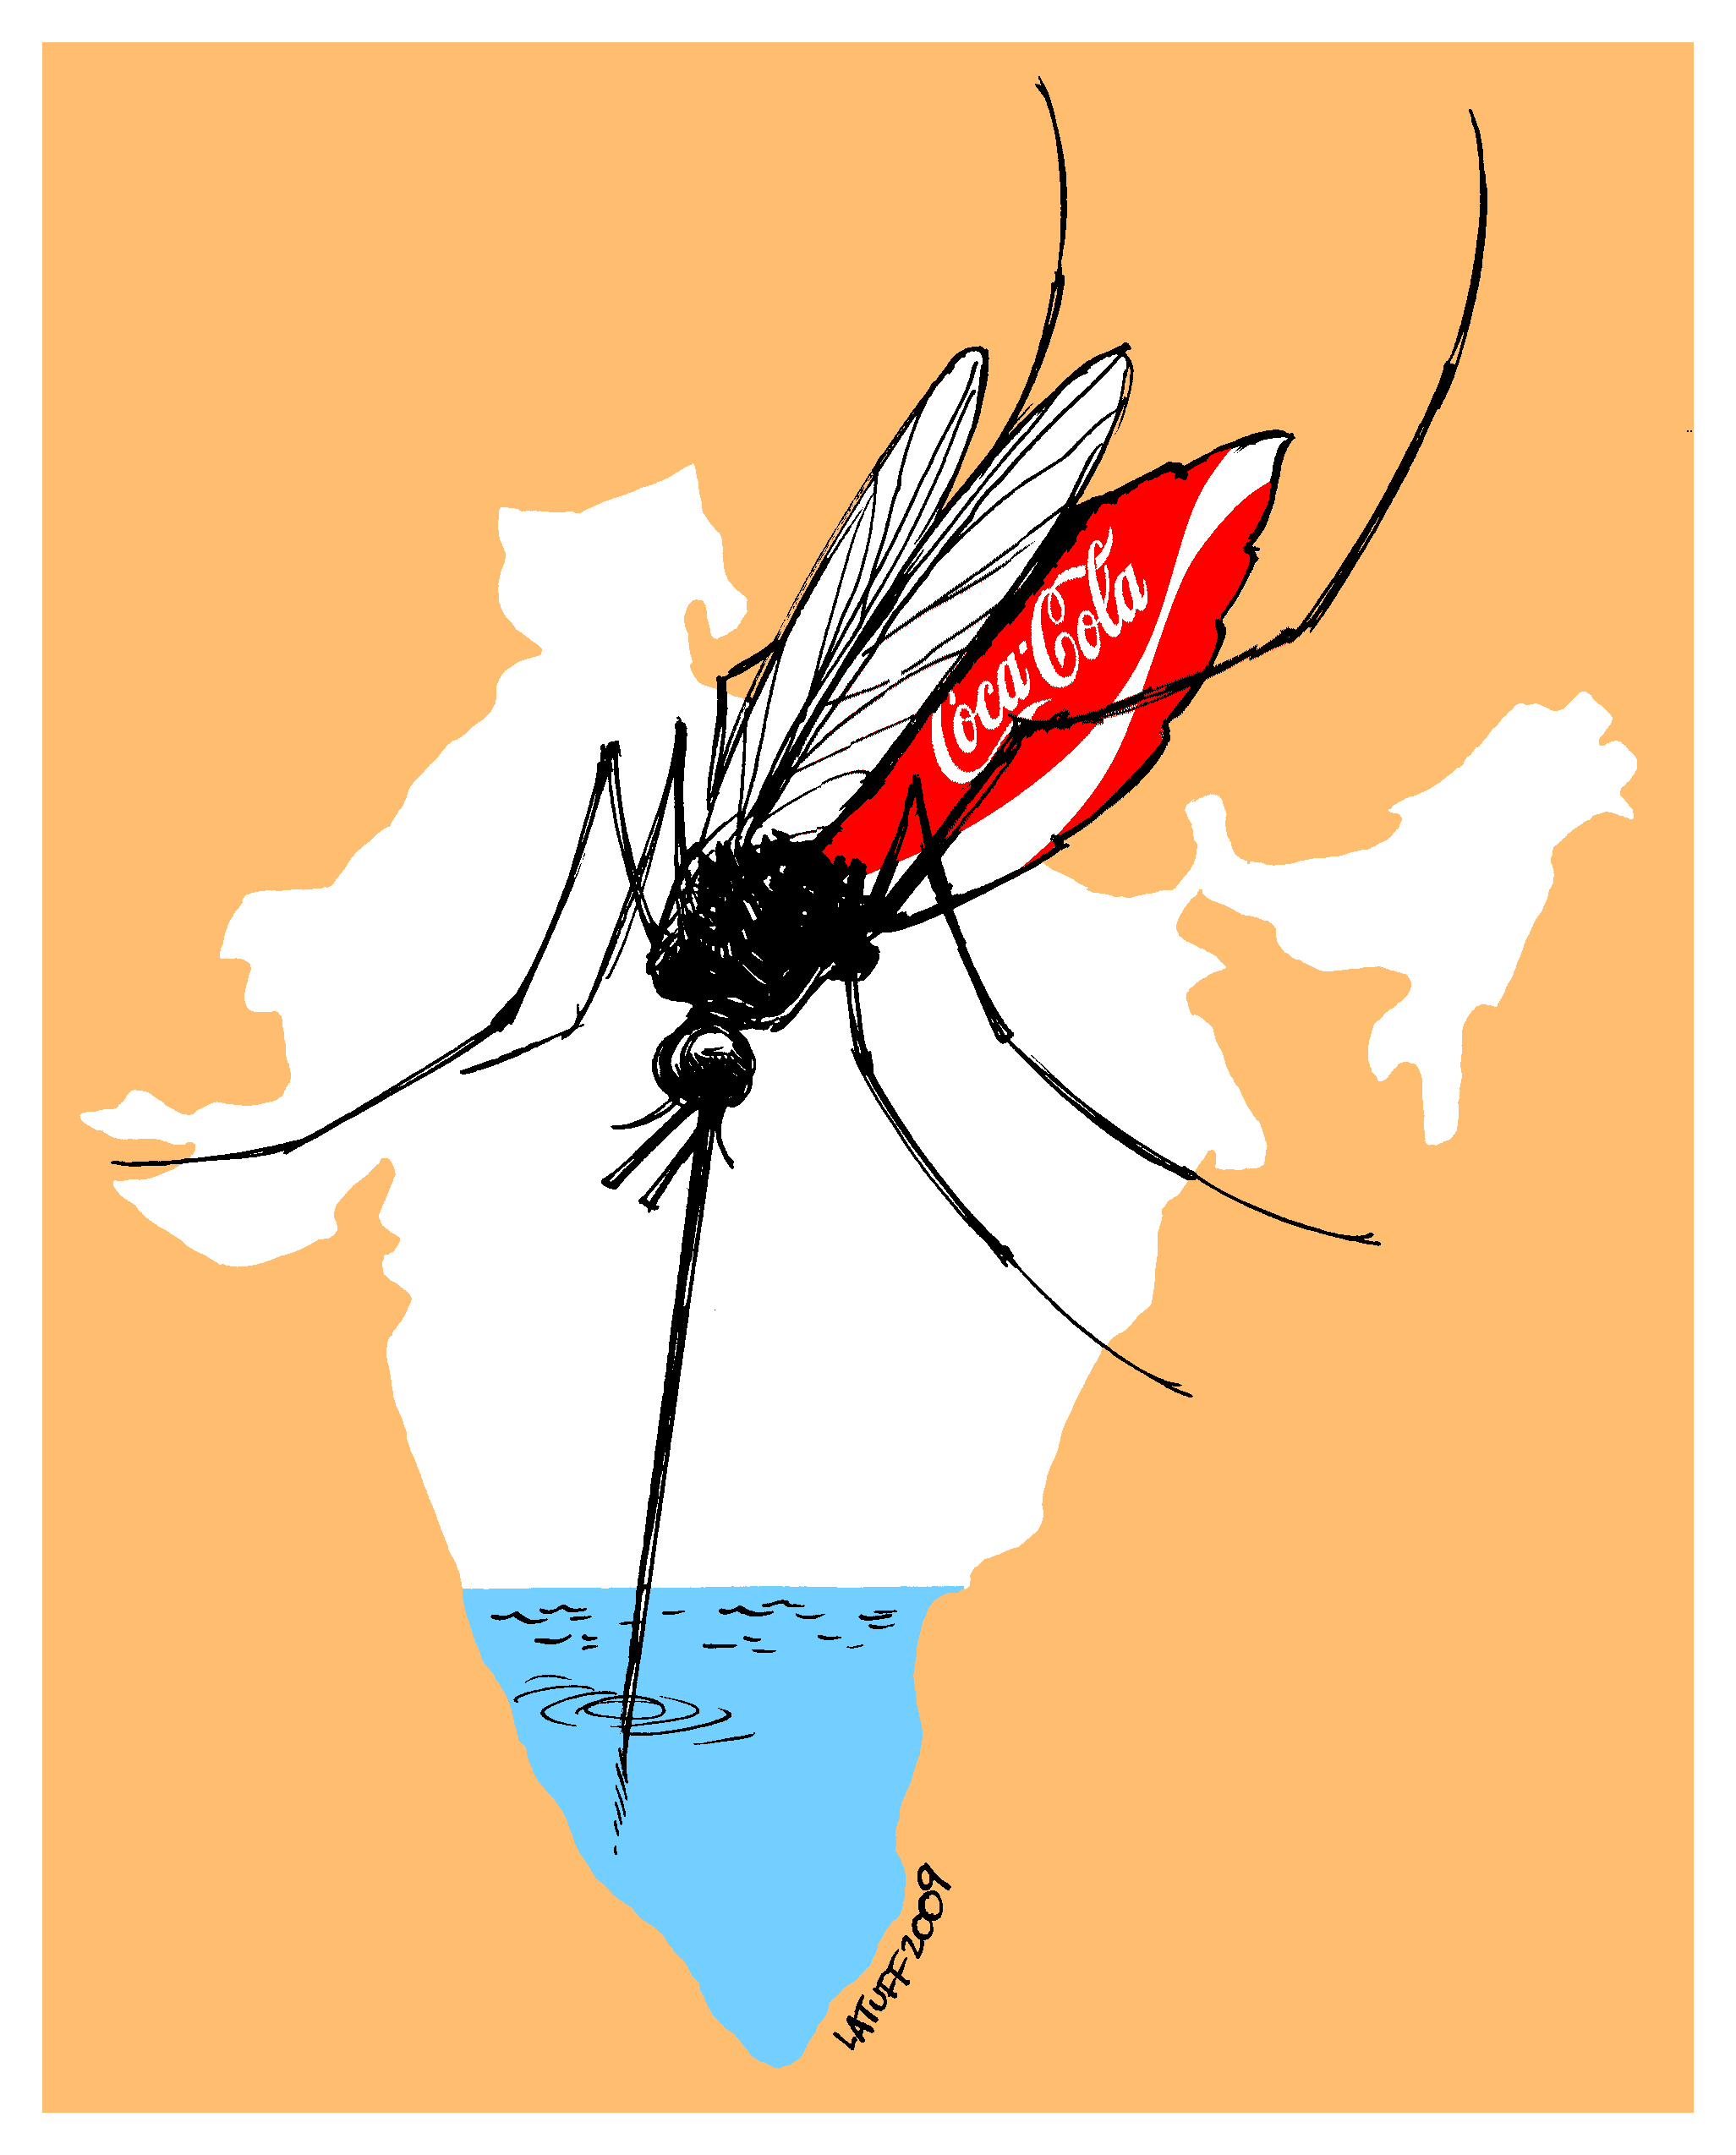
Subtopic One: Ground Water / United States [Contrast]
1. The United States has strong regulations preventing contamination of groundwater (Source).
2. Coke has generally followed these laws in the United States (Source).
3. There have been multiple instances of fines with Coke that have prevented abuse (Source).

Analysis: Why is this important? Break it down and explain to the reader – These laws have been effective because of extensive fines and penalties. Having strong laws prevents abuse because…

Evaluation: What is the bigger picture here? How does it connect to overall study? - Strict law and enforcement creates an environment where… Consequences lead to… Americans are able to exert this pressure on Coke because…

Paragraph Structure
Sentence One: Introduction to idea being discussed
Sentence Two: Evidence (*remember to add intro clause)
Sentence Three: Analyze Evidence (Break it down - What does it mean? Why is it important?)
Sentence Four: Evaluate Evidence (How does this connect to the larger subject?)
Sentence Five: Connect back to thesis (Maintaining the argument)

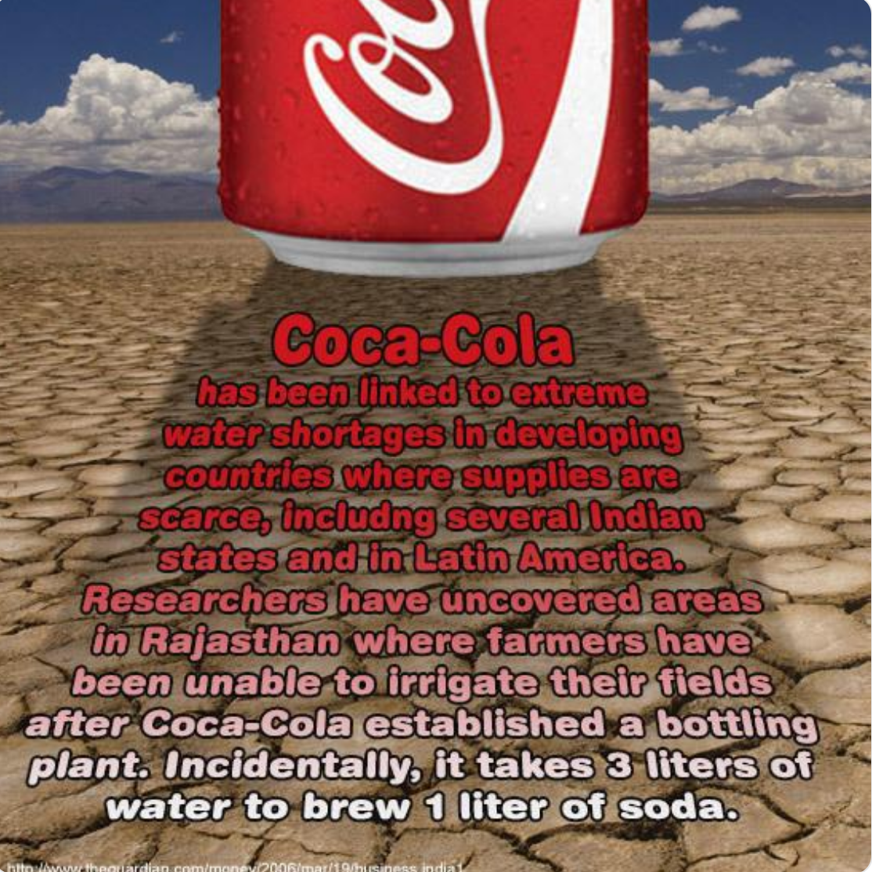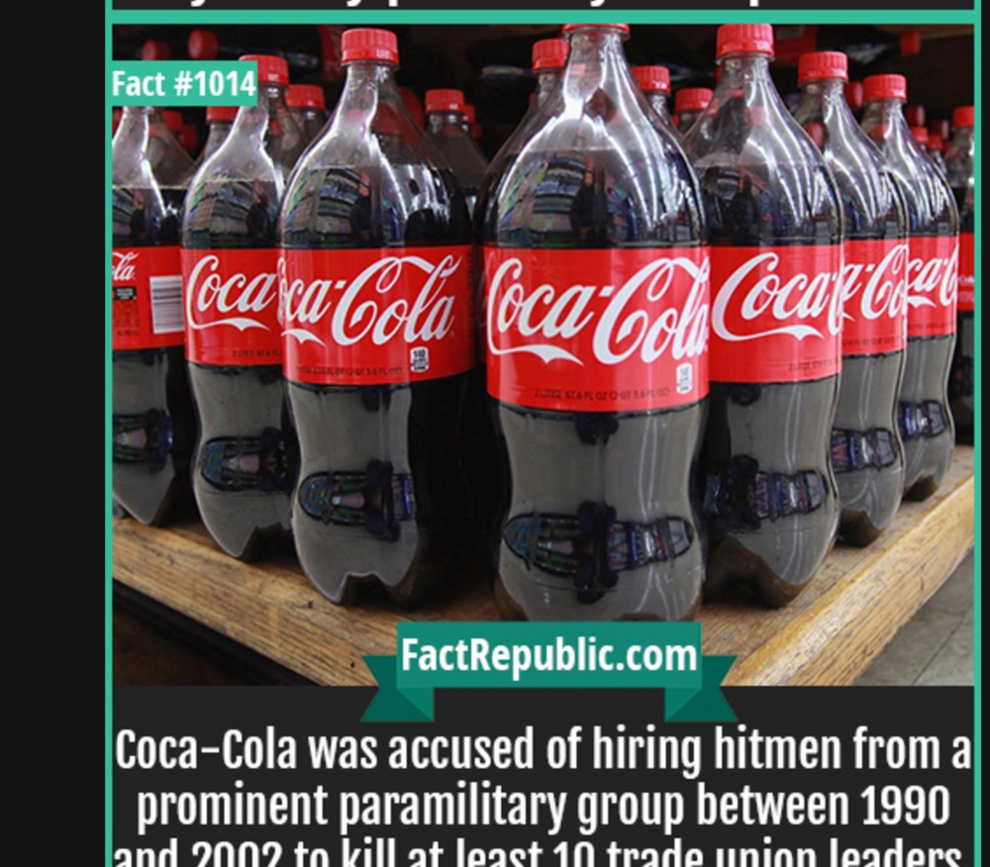

Sub Topic Two: Farming / Livelihood] Contrast]
1. (India) This contamination does more than just pollute the drinking water. Farming is the way in which most of these villagers make their living. It is their work – their livelihood. The contaminated groundwater is, in turn, contaminating the soil.
2. (US) Farmers in the US are protected through many different laws… This prevents corporations like Coke from stealing the ground water.

Evidence: 1. Coca-Cola plants in Plachimada and Mehdiganj were discovered distributing their solid waste products to local farmers under the guise of “fertilizer.” A study conducted by the BBC found these waste products to contain cadmium and lead, thus making them literal “toxic waste” products (Giridharadas 17).

2. A Personal Testimonial: “My crops and my cattle are my only wealth,” one farmer is quoted saying in an April 17 issue of The Age. “I am nothing without them. To survive they need water and water is running out” (Mukharajee 87). (

Analysis (Break it down / Explain to reader why it is important): Why is “guise of ‘fertilizer’” important? Why is cadmium and lead important? Why is it important that crops and cattle are connected to wealth? Water running out?
Evaluation (Bigger Picture / How does it connect to the larger subject and thesis): Why are they able to get away with this? What could be negative impact of consuming toxic waste? What does this tension between farmers and corporations cause? What it would mean to not be able make a living – the hopelessness that this would cause, etc.

Notes (freewrite): There is really no way to make good choices in this situation. Coca-Cola Corporation is destroying the way in which the people in these communities make their money and support their families. Farming is the only access to earning a living that these people have. They can’t go get a job at the nearest Walmart as many people in America can. Their income is dependent upon the seeds they put in the ground and what becomes of those seeds. Coca-Cola is destroying the livelihood of these farmers in multiple ways: Not only are they eliminating precious groundwater, they are contaminating what water is actually left. (Make sure to formalize language for final copy of paper.)
Analysis and Evaluation Student Samples

Student Sample One: [Introduction sentence ] The United States' Animal Welfare Act focuses on the mistreatment of animals. [Evidence with a clause before it ] These laws put into place address three ways unnecessary animal suffering can occur: “when a given research protocol is not well justified scientifically, the amount of animal suffering induced by an experiment is not strictly required to conduct the experiment, or inappropriate animal handling, housing, and feeding practices” (Latham 36). [Analysis ] Scientific justification in an experiment is important to reduce the number and unnecessary suffering of lab animals. Inappropriate handling or housing animals will also contribute to unnecessary suffering of the animals and could skew the results of experiments if a healthy vector is needed. [Evaluation and connect to thesis ] The Animal Welfare Act contributes to the 3R principle as it reduces the mistreatment and suffering of lab animals for medical research.
Student Sample Two: [Introduction sentence ] When it comes to space, NASA doesn’t do military practices; when NASA was founded, it was meant for peaceful space research. [Evidence ]The CNSA has both civilian and military components, with the military being the leading force (Solomon 312). Since the CNSA is two tiered on civilian space and military space, it’s a secret which of them is really in control (314). NASA, on the other hand, has been purely made for civilian research, and to benefit mankind (Dunbar 2). [Analysis ] This is important because this could be one of the reasons that the US doesn’t want to partner with the CNSA. It could also cause vary different research in space, which could divide the CNSA and NASA even more. In the grand scheme of things, it could cause problems down the line for both space programs. If they assisted each other, it would cause less tension and greater friendship, so the US would not be as threatened by the CNSA. [Evaluation and connect to thesis ] This seems to be the main reason the United States bans cooperation with the CNSA, so if the CNSA would be mainly a civilian space program, then the NASA and CNSA would be able to work together.
Student Sample Three: [Introduction sentences ] Comprehensive sex education is a right that should be taught in every school. When not taught properly, teenagers may engage in risky sexual behaviors that result in pregnancy and sexually transmitted diseases. For this reason, it is unethical not to give teenagers accurate and helpful information about their sexuality. [Evidence with a clause before it ] According to Santelli, “Access to complete and accurate STI, HIV/AIDS, and reproductive and sexual health information has been recognized as a basic human right and essential to realizing the human right to the highest attainable standard of health” (277). [Analysis ] The current policies in the U.S. and Japan do not effectively teach students safe sex options; instead, they just that they should avoid sex all together, which is not the answer. It causes more harm than it does good, leading to unintended consequences such as pregnancy and sexually transmitted disease. [Evaluation and connect to thesis ] The purpose of sexual education is not to encourage teens to go out and have sex, but to inform them how to safely practice it if they choose to have it.
Student Sample Four: [Introduction sentence – (General statement on larger idea) ] The second problem with the way an animator is treated in the Japanese industry is with the number of hours they work. [Evidence - (fact, quote, paraphrase, statistic) with an introduction clause before it ] Because animators are paid by number of drawings done in a day, they are incentivized to work longer hours; “On average, in-between animators work for 10 hours and 30 minutes per day; this is longer than the average working day over the whole of Japanese employment” (Daisuke 267). [Analysis and Evaluation – (Break it down, What does it mean? Why is it important? How does it connect to the larger idea?) ] Normally, working more than forty hours a week is seen as a lot, and these people are working anywhere from sixty to seventy hours a week. Normally, working this much wouldn’t be seen as a problem because the animators who entered into those positions knew what they should expect in terms of wages. [Maintain thesis (clearly connect paragraph to thesis ] However, when people are working this much and make less than the equivalent of minimum wage, it becomes a humane issue.

Student Sample Five: [Introduction sentence – (General statement on larger idea) ] One of the most effective ways China has been able to cater to its one-point-seven billion people is through their three-tier system. [Evidence - (fact, quote, paraphrase, statistic) with an introduction clause before it ] The first tier is basic coverage; the basic coverage is mostly sought after by villagers and civilians with low income (Dutta, Kang, and Sun 1618). The second tier are clinics and hospitals in heavily populated areas (Dutta, Kang, and Sun 1618). They assist those who are in need of serious medical attention and those who can afford to go directly there for aid. The third tier of their system are specialist hospitals (Dutta, Kang, and Sun 1618). [Analysis and Evaluation – (Break it down, What does it mean? Why is it important? How does it connect to the larger idea?) ] China has an efficient system because doctors and nurses of higher levels don’t have to bother with simpler treatments like first aide and checkups. With such a large population, this makes sure resources are used effectively. [Maintain thesis (clearly connect paragraph to thesis ] This is something the United States can learn from because often patients are over diagnosed because doctors are used to dealing with more pressing matters in certain areas.
Student Sample Six: [Introduction sentence – (General statement on larger idea) ] The biggest offender of homophobia thus far has to be the conservative legislation that is currently enacted in Russia. [Evidence - (fact, quote, paraphrase, statistic) with an introduction clause before it ] At the top of the list is the “anti-gay propaganda” law. This law intends to prevent the exposure of minors to “non-traditional sexual relations,” (Rivkin-Fish and Hartblay 96). [Analysis – (Break it down, What does it mean?) ] Since the legislative body has decided that same-sex relationships and the depictions of them are dangerous to children, LGBT people are made out to be insidious threats to the youth. Evidence - (fact, quote, paraphrase, statistic) with an introduction clause before it ] This leads to the general public feeling “aggression against the LGBT community has been sanctioned by the government,” (Soboleva and Bakhmetjev 281). [Analysis – (Break it down, What does it mean?) ] It makes sense that those who commit crimes against same-sex attracted people feel they are in the right to do so given this information. [Evaluation / Maintain thesis (clearly connect paragraph to thesis) ]Without acknowledging that LGBT people are deserving of fundamental human rights, the cycle of discrimination and persecution will continue, endangering more people.
Student Sample Seven: [Introduction sentence – (General statement on larger idea) ] Japan and the United States have similar statistics on the type of women who are more likely to pursue positions in government. [Evidence - (fact, quote, paraphrase, statistic) with an introduction clause before it ] This does create some more problems with representation, as the women who are likely to campaign or volunteer come from more privileged middle or upper class backgrounds, higher education, and tend to be housewives, older or retired (Kage, Rosenbluth and Tanaka 5). Male politicians in Japan and the United States are less likely to want to nominate women for positions, suggest they run for office, or support them once they are in government (Fox and Lawless 406). [Analysis and Evaluation – (Break it down, What does it mean? Why is it important? How does it connect to the larger idea?) ] Issues of equality amongst genders are not exclusive to Japan and United States, but so-called developed nations having such a stark divide in support and representation is that much more striking. [Evaluation / Maintain thesis (clearly connect paragraph to thesis) ] If either of these two countries want a more active and more representative government, they need to acknowledge the gender biases that may prevent or deter women from joining government and work on solutions that may allow for fairer representation.

MLA In-Text Citation Rules:

- In general, use (Author’s Last Name Page #) format. [No comma or year needed]
- If you use that source multiple times in the same paragraph without referencing another text, then just use page number (Page #).
- Period comes after the citation.
When writing the body of a research paper, it is important to use a sentence like this one to introduce the research. One important rule of in-text citation is to “use the author’s name and page number after the quote” (Dories 7). When referring to that same work in a paragraph, and there is no other reference in between, “just use a page number without a name” (8). After a quote or paraphrase, use a few sentences analyzing the information (What does it mean?), evaluating the information (How does it relate to the larger subject?), and connect it to the thesis. At the end of each paragraph, it is important to include a sentence directly connecting to the thesis to maintain continuity and avoid straying off topic.
- If multiple authors, use the following format (Author, Author, and Author Page #).
- If there is not an author, use the following (“Title” Page #).
- If there are more than three authors, use the following (Author, et al. Page #).
- For other examples, see Purdue Owl.
The clause that begins a sentence can be as simple as this, introducing information in a basic way. If there is no author, “use a shortened version of the title in quotation marks with a page number” (“Citation” 9). Make sure to add lines of analysis, evaluation, and connect to the thesis here. Then, consider the idea of multiple authors who “say important things” (Smith, Jones, and Dories 51). Continue to add analysis and evaluation. Then refer to another work from geniuses “about citing more than three authors in one work” (Smith, et al. 43). Make sure to add more analysis and evaluation. Then, connect back to the thesis to maintain continuity.

Purdue Owl Handout

Purdue Owl is an invaluable resource for every college student. Purdue Owl is located at: https://owl.purdue.edu/owl/purdue_owl.html or by Googling “Purdue Owl”. For our purposes, click on “MLA Guide”, then “MLA Formatting and Style Guide”. Use the menu on the left side to navigate through the resources. Here are the primary pages we will use this semester:
1. General Format: The format of your paper and first page (margins, font, etc.).

2. MLA In-Text Citations: This page focuses on basic rules of in-text citation, common knowledge, and examples.
3. MLA Forming Quotations: For the purposes of our class, focus on “Short Quotations” and limit all quotations to no more than 2-3 lines of text. Larger quotations should not be used in short papers.
4. MLA Works Cited Page – Basic Format: Basic rules and format for Works Cited page.
5. MLA Works Cited Electronic Sources: This page should be used for any resource on the web, from web pages, to entire web cites, to magazines, images, and databases.
6. MLA Works Cited – Other Common Sources: This page should be used for other sources like: interviews, films, songs, television show, podcast, paintings, and similar.
7. MLA Sample Works Cited and Sample Paper: Use these resources for general formatting. Because we are writing short papers, ignore: sub-headings, footnotes, and block quotes.
8. MLA FAQs: This section has many instructions that are not listed in other places, such as: citing e-mail, tweets, dictionary, Constitution, etc.

Avoiding Plagiarism / Paraphrase Techniques

Definition of Plagiarism: Unacknowledged borrowing of ideas, facts, phrases, wordings, or whole words in a paper (from books, on-line, or any other source), as well as the copying of another student’s work, or using the same work in multiple classes without notifying the professor, all constitute plagiarism and are unacceptable in the university community.
Consequences: Students turning in plagiarized work may receive a failing grade for the essay or for the course. It is standard policy that any form of plagiarism be reported to the University. Also, all papers turned in will be submitted to plagiarism software to check for authenticity as well as any other means necessary. For more information, see the university policy on plagiarism, or ask me.

Strategies for Avoiding Plagiarism:
1. Put quotations around any unique phrasing that comes directly from the text.

2. Paraphrase, but be sure to not just rearrange or replace a few words. Instead, read over section to paraphrase carefully; cover up the text with your hand, or close the text so you can’t see any of it (and so aren’t tempted to use the text as a “guide”). Write out the idea in your own words without peeking.

3. Check your paraphrase against the original text to be sure you have not accidentally used the same phrases or words and that the information is accurate.

4. *If you quote or paraphrase, make sure that there is a citation on every 1-2 lines of text.*
What to Avoid:

1. Merely changing around a few words and phrases, or just the order of the original sentences.

2. Only putting one citation at the end of a paragraph.
3. Using unique phrasing without quotation marks.

Common Knowledge:

Definition: facts that can be found in numerous places and are likely known by a lot of people.

Example: John F. Kennedy was elected President of the United States in 1960.
This is generally known information. Even if you do not know it, it is reasonable to assume that a large percentage of the population does.
For the Purpose of our Class: If approximately 25 percent of students would know the idea, it could be considered common knowledge.

Paraphrasing Worksheet: Sony Releases New Product – Nose Buds by John Smith
Original Text: Hailing the product as a revolution in smelling technology, Sony released its sleek new line of nose buds Monday, which will allow consumers to blast a variety of scents directly into their nostrils whenever and wherever they please. The new Sony Nasal HD-340s, which retail for $49.99, have been designed to comfortably fit into users’ nostrils and are said to rely on advanced olfactory technology to deliver a wide array of high-quality aromas, including lavender, fresh-baked bread, tennis ball, Fourth of July barbecue, and public pool, offering each user a highly personalized smelling experience.
Read the following paraphrase and answer the questions afterwards:
1. In a widely unexpected move, Sony has put out a new product that will transform the daily lives of many Americans. Their new product, nose buds, will change the way people experience the world, allowing people to choose the odors that they interact with on a daily basis and avoid those that they do not want to interact with (Smith 1). The product sells for an unexpectedly low $49.99, which means that average people will have access to this new technology (1).
Is the previous paraphrase correct or incorrect? Why?

2. Sony has released a brand new smelling technology called nose buds, which allows the user to personalize their smelling experience. Users will be able to smell many of their favorite odors such as: lavender, baked bread, or barbecue (Smith 1). This new product will revolutionize watching movies, walking through city neighborhoods, and many other aspects of daily life.
Is the previous paraphrase correct or incorrect? Why?
3. In a widely unexpected move, Sony has introduced a new product that will impact millions of people. Their new invention, nose buds, will change the way people experience the world, allowing them to choose the odors that they interact with on a daily basis. Some of the scents Sony will offer include: “lavender, fresh-baked bread, tennis ball, Fourth of July barbecue, and public pool” (Smith 1). The product sells for an unexpectedly low $49.99, which means that average people will have access to this new technology (1).
Is the previous paraphrase correct or incorrect? Why?

Paper Topic Worksheet – Sample
Paper Topic: Secondary Education in the US and China

Research Question / Tentative Thesis: What explains the achievement gap between students in the US and China at the secondary level?

Sub-Topic One: Testing
Compare:
A. Both countries have tests that are administered via the government
B. Most classes at the secondary level are geared to help students achieve high test results.
Contrast:
A. In China tutoring services help with tutoring in this way, but in the US, it is this way…
B. While scores show this, the reality is often this…
Sub-Topic Two: Achievement Gap Between Wealthy and Poor Students
Compare:
A. Students who are wealthy do this… China… US…
B. Students who are poor do this … China … US …
Contrast:
A. Even though both countries have achievement gaps, because of extreme poverty, there is a much larger gap in China.
B. Because China has a larger population….
Sub-Topic Three (Optional): How Personal Life Impacts Test scores
Compare:
A. Both American and Chinese youth have pressures because of…
B. Divorce rate is high in the US and it is impacting…
Contrast:
A. The average American student has a job working XX hours a week, while the average Chinese student does not…
B. Because the average American has more wealth, they have advantages in this way…

How to Write an Introduction / Thesis

Thesis: A good thesis is specific:
[Weak] Arranged marriages in India are unethical.
[Good] Arranged marriages in India prevent women from reaching their full potential in higher education.

A thesis is NOT an announcement of the subject:
[Weak] My subject is rape in South Africa.
[Good] In order to slow down the rape epidemic in South Africa, it is important to start a comprehensive education program focused on boys in elementary school.

A thesis is NOT a statement of absolute fact: [Weak] Rape is common throughout South Africa

The Purpose of the Introduction:

Introduce your topic / Create interest
Provide necessary (but limited) background information
Preview the rest of your essay
Introduction should move from general more specific most specific (thesis)

The thesis statement will identify the main idea and preview the rest of the essay. Remember that this is most often either one or two sentences. The thesis is usually at the end of the introduction paragraph. The other sentences in the introduction introduce the topic, create interest, and provide necessary (but limited) background information. Explain why the reader should care – State why the main idea is important –show the reader why s/he should care and keep reading. Your goal is to create a compelling, clear, and convincing essay people will want to read and act upon

Sound Proofs: The thesis is more than a general statement about the main idea. It needs to establish a clear position that will be supported with balanced proofs: logos (logic / sound reasoning: induction, deduction), pathos (balanced emotional appeal), and ethos (author credibility).
Length: The introduction, as with all paragraphs in the essay, should be approximately ½ of a double spaced page in Microsoft Word.

How to Write an Introduction / Thesis – Argument Paper

Thesis must be debatable. An argumentative or persuasive piece of writing must begin with a debatable thesis or claim. In other words, the thesis must be something that people could reasonably have differing opinions on. If your thesis is something that is generally agreed upon or accepted as fact then there is no reason to try to persuade people.

Example of a non-debatable thesis statement: Pollution is bad for the environment.

This thesis statement is not debatable. First, the word pollution means that something is bad or negative in some way. Further, all studies agree that pollution is a problem; they simply disagree on the impact it will have or the scope of the problem. No one could reasonably argue that pollution is good.

Example of a debatable thesis statement: At least 25 percent of the federal budget should be spent on limiting pollution.
This is an example of a debatable thesis because reasonable people could disagree with it. Some people might think that this is how we should spend the nation's money. Others might feel that we should be spending more money on education. Still others could argue that corporations, not the government, should be paying to limit pollution.

Another example of a debatable thesis statement: America's anti-pollution efforts should focus on privately owned cars.

In this example, there is also room for disagreement between rational individuals. Some citizens might think focusing on recycling programs rather than private automobiles is the most effective strategy.
How to Write a Conclusion

Conclusions wrap up the ideas in a paper. After moving from general to specific information in the introduction and body paragraphs, the conclusion should begin pulling back into more general information that restates the main points of your argument. Outline:

Restate the topic, main ideas, and why they are important; Restate the thesis idea;
Address opposing viewpoints; explain why readers should align with presented position (If applicable); Call for action (if applicable)

Once you accomplish these tasks, you are finished. Do not try to solve world hunger in the final sentence of your conclusion. Simplicity is best for a clear, convincing message. The most important rule for conclusions: Do not add any new information. Only use what you have already proven in the paper.

Suggestions for Paper One

Introductions: 1. Have a good hook that draws the reader into the paper 2. Use a balance of logos / pathos / ethos 3. Introduce topic, create interest, and provide necessary (but limited) background information.
Follow MLA citation instructions, in-text citation examples, and format paper correctly. The paper needs to be 5 body pages and a works cited, double-spaced, in Times New Roman font, without extra spaces anywhere in the paper. Example: Basic in-text citation is author and page number (Dories 3).
Make sure that quotations do not stand alone – every quotation should have a clause before or after it. Examples: Incorrect: “This quotation is wrong.”
Correct: According to Dr. Dories, “this quotation is right” (3).
Reread plagiarism instructions: everything that is from a source needs to be in quotes. For paraphrasing, make sure that the new phrasing is in your own words and still cite the text paraphrased. In both cases, every sentence that is quoted or paraphrased needs a citation. Throughout the paper, any sentence that has information from sources that is not common knowledge needs to have a citation. If it looks like you have too many citations, then it most likely means you need to add more analysis / evaluation.
General rule: for every sentence that is quoted / paraphrased, introduce the information, analyze the information (What does it mean? Why is it important?), and evaluate the information (How does it connect to the larger idea or subject?).
Sources: A minimum of 7 sources are required for this paper – at least 5 peer reviewed academic journal articles and 2 other trustworthy sources. Because this is a research course, each missing source will reduce the grade by 10 percent and the paper will not be accepted without academic sources.
Works Cited: Begin Works Cited on a separate page. Title should be Works Cited in normal 12 point Times New Roman font. All entries are alphabetical and double spaced without extra spaces. Each entry should have a hanging indent (see In-Text Citation Handout or Purdue Owl). Important: If you are using a Works Cited generator, make sure to check it against a sample. Most common errors from generators: missing page numbers, formatting, and ALL CAPS.
Paragraphs: For our purposes, paragraphs should be approximately ½ of a double spaced page.

MLA Guidelines for Paper Format

1. Set margins of your document to 1 inch on top and bottom, 1 inch on the left and right
2. Create a header in the upper right-hand corner that includes your last name, followed by a space with a page number; number all pages consecutively with Arabic numerals (1, 2, 3, 4, etc.), one-half inch from the top and flush with the right margin.
Double-space the text of your paper, and use 12 pt. Times New Roman font.

3. Do not make a separate title page for your paper.
4. In the upper left-hand corner of the first page, list your name, your instructor’s name, the course, and the date. Again, be sure to use double-spaced text with no extra spaces.

5. Double space again and center the title. Do not underline, italicize, or place your title in quotation marks; write the title in Title Case (standard capitalization), not in all capital letters.

6. Indent the first line of paragraphs one half-inch from the left margin.

7. Use italics throughout your essay for the titles of longer works (Name of book, Name of Journal).

8. Use quotation marks for titles of shorter works (“Title of article”).

Works Cited Page - Basic Rules

1. Begin Works Cited page on a separate page at the end of the research paper. It should have the same margins, last name, and page number header as the rest of your paper.

2. Label the page Works Cited (do not italicize the words Works Cited or put them in quotation marks) and center the words Works Cited at the top of the page.

3. Double space all citations, but do not skip extra spaces between entries.

4. Indent the second and subsequent lines of citations five spaces so that you create a hanging indent.

5. All entries should be listed in Alphabetical order

6. Important: If you are using a Works Cited generator, make sure to check it against a sample. Most common errors from generators: missing page numbers, formatting, and ALL CAPS.

Specific Cases

A works cited page is a list of all of the sources you have used in the process of researching your work. In general, it should include:

Authors’ names.
Titles of the works.

Names and location of the company that published your copy of the sources.

Dates your copies were published.

Page numbers of your sources.

In general, the works are arranged in the above order. Here are some examples:

A Book:

Author (Last name, First Name). Title of Book in Italics. Location: Publisher, Year.

Dories, Jeff. How to Fail an English Course. Indiana, PA: Indiana University of Pennsylvania Publishing, 2010.
A Magazine:

Author (Last name, First Name). “Title of Article.” Title of Periodical. Day Month Year: pages. Medium of publication. If web, date of access.
Gaga, Lady. “How to Wear Almost any Food and Look Fabulous.” Time. 20 Nov. 2010: 70-71. Web 20 September 2010.
*Scholarly Journal*:
Author (Last name, First Name). “Title of Article.” Title of Journal. Volume, Issue, Year: pages. Medium of publication. Doi (if available). Date of Access.
Shulte, Bret. “Justin Bieber and Thermonuclear Physics.” The Journal of Pop Stars and Nuclear Physics, vol. 5, no. 3, 2013, pp. 13-19. Pitt Cat+, doi:10.1017/S0016216X06305986. Accessed 27 May 2016.
Student Name
Dr. Jeff Dories
Course / Assignment
15 January 2017
In Text Citation Examples
An introduction to a research paper should introduce the topic, create interest, provide necessary (but limited) background information, and preview the rest of the essay. It should move from general to more specific information, ending in the thesis. The thesis is more than a general statement about the main idea. It needs to establish a clear position that is supported with balanced proofs (logos / logic, pathos / emotional appeal, and ethos / authorial credibility). A strong thesis is specific. It is not a mere announcement of the subject or a statement of fact. It should also make clear why the reader should care about the topic. Finally, in most cases, the last sentence or two of the introduction will include a balanced (logos, pathos, and ethos) thesis.
When writing the body of a research paper, it is important to use a sentence like this one to introduce the research. One important rule of in-text citation is to “use the author’s name and page number after the quote” (Dories 7). After a quote or paraphrase, use a few sentences analyzing the information (breaking it down), evaluating it (the bigger picture), and connecting it back to the thesis. Throughout this process, avoid phrases like “in my opinion” or “I believe” as it weakens the authorial ethos. Instead, use the information provided to make reasonable judgments as fact. An important aspect of the information above is that for any quote in the entire paper, there must be a clause introducing or concluding the sentence. Add a sentence here that maintains the thesis here.
The clause that begins a sentence can be as simple as this, introducing information from Dr. Dories like, “when referring to an author in the sentence, do not put the name in parenthesis afterwards” (7). In this next sentence, while paraphrasing a brilliant idea from a text Dr. Dories wrote, it still needs a page number (8). In this space, would be a few lines of analysis, evaluation, and connecting this information back to the thesis. Next, add some common knowledge, which is generally thought of as any idea that a majority of readers would know as fact. Common knowledge does not need to be cited. Add a sentence here that maintains the thesis here.
If there is no author, “use a shortened version of the title in quotation marks with a page number” (“Citation” 9). The sentence preceding this one was effective because it teaches citation. Citation is an important skill to learn, to avoid accidental plagiarism. To learn more about this topic, the video An Inconvenient Citation by I. Phil Osophize is a good instructional resource. The movie follows the difficulties of summarizing. Then, it is important to analyze the film and how it fits in with the thesis (Osophize, “Inconvenient”). The final scene of the movie emphasizes the importance of the thesis and the analysis following it. Every paragraph throughout the paper should connect to the thesis in some way.
Conclusions wrap up the ideas presented in the paper. After moving from general to specific information in the introduction and body paragraphs, the conclusion should begin pulling back into more general information that restates the main points of the argument. Conclusions may also call for action or overview future possible research. In a general way, restate the topic and why it is important, restate the thesis/claim, quickly address opposing viewpoints and explain why readers should align with the position advocated, call for action or overview future research possibilities. Remember that once these tasks are accomplished, unless otherwise directed by the instructor, the paper is finished. Don’t try to bring in new points, end with a whiz-bang conclusion, or try to solve world hunger in the final sentence of the conclusion. Simplicity is best for a clear, convincing message.

Works Cited
Clinton, Bill. “Bill Clinton’s South Park Addiction.” New York Times. May 2011. Academic Search Premier. Web. 25 May 2016.
Ebert, Roger. “The Worst Movie.” Sun-Times News Group. 2 June 2011. Ebscohost. Web. 24 May 2016.
GlobalWarming.org. Cooler Heads Coalition, 2014. Web. 24 May 2016.
Gowdy, John. “The Hunger Games: Feast or Famine.” International Journal of Child Competition, vol. 50, no. 1, 2012, pp. 173-96. Pitt Cat+, doi:10.1017/S0014746X02003960. Accessed 27 May 20016.
“Grasshoppers with Grenades.” Environmental Defense Fund. 8 May 2015. Web. 24 May 2016.
Leroux, Marcel. Gravity, Myth Or Reality: The Ups and Downs of Gravity Belief. New York: Springer, 2015. Print.
Nordhaus, William D. “Alternative Dentistry: Other ways to Gain Access to the Mouth.” American Economic Review, vol. 48, no. 3, 2014, pp. 123-26. EbscoHost, doi:10.1017/S0058243X04005926. Accessed 27 May 2016.
---. “The Round Earth Myth: Why we Should not Believe the Round Earthers.” Science, vol. 12, no. 8, 2012, pp. 72-73. ProQuest, doi:10.1017/S0012246X03005566. Accessed 24 May 2016.
Shulte, Bret. “Justin Bieber and Thermonuclear Physics.” The Journal of Pop Stars and Nuclear Physics, vol. 5, no. 3, 2013, pp. 13-19. Pitt Cat+, doi:10.1017/S0016216X06305986. Accessed 27 May 2016.
Uzawa, Hirofumi. Is Snooki Smarter than us? Life Lessons from the Shore of Jersey. Cambridge: Cambridge UP, 2013. Print.

Aristotelian Appeals: Logos, Ethos, Pathos

Rhetoric: To make visible and identify the means of persuasion.
Rhetorical Appeals: Persuasive strategies used in arguments to support claims and respond to opposing arguments. A strong argument will generally use a combination of all three appeals.

Logos (Text / Speech) Logic of the argument A B C

Common appeals to Logos:
Scientific facts or theories
Historical analogy
Data or statistics
Quotations
Citations from experts and authorities
Real life examples
Personal anecdotes
Definitions
Informed opinion
Indicated reasoning (Because of … This is true)

Ethos (Writer / Speaker) The credibility, character, authority of the speaker

Common Appeals to Ethos:
Author’s profession / background
Author’s publications
Appearing sincere and knowledgeable
Conceding to opposition when appropriate
Morally / Ethically believable
Appropriate language for audience and subject
Appropriate vocabulary
Correct grammar
Professional format

Pathos (Audience) Connecting with the audience in an emotional manner

Common appeals to Pathos:
Emotionally loaded language or pictures
Vivid descriptions
Emotional examples
Anecdotes, testimonies, or narratives about emotional experiences or events
Figurative language
Emotional tone (humor, disappointment, excitement)
Pair and Share Please share the ad that you chose with a partner. What appeals are used? [Ethos, Pathos, Logos]. Are they effective? Why or why not?

Goals:
- Reinforce knowledge of rhetorical appeals
- Learn some of the ways rhetorical appeals are used

Aristotelian Appeals: Logos, Ethos, Pathos (Continued)

Logos: The first rhetorical appeal is based in logic. A logical appeal uses facts and statistics to make a reasonable claim that can be confirmed by experts. For example, a research paper on climate change, might use statistics from a report on CO² in the atmosphere. A strong research paper will use different kinds of evidence for strong logos (facts, data, analysis, etc.).
Avoid biased or untrustworthy sources to maintain a strong logos. Evaluate all evidence and data to determine trustworthiness. For example, a survey with a sample size of 2000 would be more reliable than a sample size of 4 in most cases. Also, try to find out methodology of the study; what methods did they use to gather data?
A logical argument must also be reasonable. The author’s claims need to be supported by facts and data to maintain a strong logos. For example, a paper could discuss cat and dog allergies by describing the symptoms of allergies and that thirty percent of people in the US have these allergies. If the author then concludes that cat and dog ownership should be banned in the US, the claim is so extreme that it undermines the argument. Banning cats and dogs is unlikely, ignores the positive benefits of the animals, and is therefore an unreasonable claim that weakens logos.

Ethos: The primary focus of a rhetorical appeal based on ethos is establishing credibility. Think about what factors or qualities make someone an expert or reliable.
The most important form of credibility in research papers is professional credentials. Does the person have a terminal degree in their field? (PhD, etc.). Have they been working in that field for a long period of time? Is their work in peer reviewed academic journals? For example, an article on weight loss written by a nutrition blogger without a terminal degree would be a lot less trustworthy than one written by a nutritionist who has a doctorate, been in the field for a decade, and has published in academic journals.
The type of writing also determines what best establishes ethos. For example, in a class that is focused on college level research papers, then the factors listed above would be best. For a less formal assignment, in a high school or non-research focused class, it might be acceptable to use evidence from someone with experience, yet does not have a terminal degree. An example of this might be a prize winning farmer who is writing about methods of raising cattle.
In general, when faced with any new information, ask ethos related questions. Who is providing this information? Are they reliable? How do you know? Also, keep in mind that strong ethos does not automatically mean that evidence is valid. There are disagreements within fields and many people who have terminal degrees make claims outside of their expertise.

Pathos: The third rhetorical appeal, pathos, is an appeal to emotion. It is commonly used in advertisements and media in western individualistic cultures who often value emotions as an expression of individualism (See Hofstede Insights web page). One way that writers can appeal to ethos is through word choice. For example, if a student is devastated, it is much worse than a student feeling bad. Be careful and precise with word choice to develop a balanced pathos appeal.
Often, writers will use personal anecdotes rather than statistics to appeal to pathos as it makes an emotional connection with the reader. For example, if a person is merely asked to donate to people in need in Haiti, they are less likely to donate, then if they are given a photo of a child from Haiti and told their donation will benefit that child.
Appeals to pathos are powerful, but using too much pathos may turn the reader away from the argument. The reader may assume that the writer is using too much pathos to make up for a lack of strong evidence and credibility. It is best to use pathos to support your evidence rather than in place of it.
Types of Evidence

Authors can choose from a variety of types of evidence in order to support their thesis. Some types of evidence are: anecdotes, descriptions, examples, expert analysis, facts, reflections, and statistics. Often these types of evidence overlap. It is best to use different types of evidence throughout the paper to make a stronger claim.

Facts are information that experts agree to be true such as historical events or scientific evidence. For example, John F. Kennedy was elected president in 1960. Or, there are 206 bones in the adult human body.

Common Knowledge are facts that can be found in numerous places and are likely known by a lot of people. Example: The Declaration of Independence was signed on July 4, 1776 . This is generally known information. Even if you do not know it, it is reasonable to assume that a large percentage of the population does. For the Purpose of our Class: If approximately 25 percent of students would know the idea, and the information is correct, it could be considered common knowledge.

Anecdotes are examples told in story form. Often, authors tell a story from their life in the form of an anecdote to support their thesis.

Descriptions explain appearance of something in words that appeal to the senses.

Examples are specific details are used to demonstrate a point. Often examples begin with the phrases for example or for instance. Realistic hypothetical examples can also be used. A hypothetical example is one that does not exist, but it is reasonable and realistic.

Expert analysis is a statement from someone with extensive knowledge on a subject. For example, to write a paper on climate change, it would support the paper to get a statement from an expert who has a PhD in climate science and extensive career experience in the field. This would strengthen the ethos of the paper.

Statistics are numbers or percentages that represent researched data. For example, the population of a town or survey responses.

Examples of Strong Introductions for Research Writing MLA Format
Example One
The current conflicts in the Middle East have caused increased awareness of the effects of Traumatic Brain Injury (TBI), Post-traumatic Stress Disorder (PTSD), and other “invisible wounds” (Jaffee and Meyer 1291). The term “invisible wounds” include mental health conditions such as PTSD, depression, suicide, and TBI (Wieland, Hursey, and Delgado 4). It is important to study the impact of these “invisible wounds” in order to increase knowledge of PTSD and long-term trauma experiences and its effects on the mentality of civilians in a trauma-stricken area. By studying not only United States soldiers’ experiences with PTSD, but PTSD experienced by the Palestinian people as well, it will be easier to create a more varied approach of treating this disorder.
Example Two
In 2009, American Evangelical Scott Lively headlined a Christian conference in Uganda. His section of the conference was about the evils of the “gay agenda” (Foster and Simmons 45). Other American Evangelicals supported Lively, as well as the Ugandan government’s endorsement of their infamous anti-sodomy laws. One month after the conference, which was presented to many people, including government officials, a new bill was introduced in Uganda. The Anti-Homosexuality Bill would make homosexual acts committed in Uganda crimes punishable by life in prison, and in some cases, death (48). The hate-speech that these people are uttering is spreading all over the world, and is ultimately resulting in radical events that contradict the predominant Christian value of “love thy neighbor.”
Example Three
With fashion and retail markets facing the effects of recent economic downturn here in the US, the ever-evolving fashion industry is seeking out new areas of potential growth and prosperity. In the midst of global recession, the Middle East is creating an environment for the luxury fashion market to flourish. In a study in 2009 organized by Esmond University, a French fashion institute with a branch in Dubai, revealed that the United Arab Emirates was quickly becoming a premiere fashion market within the Middle Eastern region (Seymour 52). The article “Arab Fashion” in Middle East Quarterly explained, “After India, Russia, and China, the UAE is the 4th most valuable retail market in the world” (52). With retail markets here in the US shifting towards a mass fashion appeal, key markets such as Dubai are designating the Middle East as one of the most valuable fashion destinations in the world.

Paper Two Argument Based on a News Video

The art of argumentation is not an easy skill to acquire. Many people might think that if one simply has an opinion, one can argue it effectively, and these folks are always surprised when others don’t agree with them because their logic seems so correct. Additionally, writers of argumentation often forget that their primary purpose in an argument is to sway the reader to accept their point of view. It is easy to name call, to ignore the point of view, or to accept one’s own opinion as gospel, even if the writer has not checked his or her premise in a couple of years. This is also true with many young writers who have not questioned the beliefs inherited from others.

Want to know what you think about something? Then, write an argumentative essay. Avoid writing about issues that cannot be won, no matter how strongly you may feel about them. Also, care should be taken that after thinking about one side of an issue, think through the other side as well. Far too many individuals only think about the side that they already believe in. This hurts the strength of the argument because they are not addressing the concerns of someone that does not agree with them or the people that they are trying to convince. You do not need to write about the opposing position. Instead, think about how to convince someone with an opposing viewpoint as you write the paper.

So, what do you write about? The paper will be based on a country from a non-western culture. You will watch news videos from a non-western country and find a topic of interest. The topic can be loosely tied to the video or can change somewhat with research, but you must start with a news video.

The issue must be an arguable claim that a reasonable person could disagree with. If it is not an issue that a reasonable person could disagree with, then it does not fulfill the requirement to persuade someone to this point of view.

A clear position taken by the writer with strong ethos. In the thesis sentence, state the position. You should not write: “I believe that the toilet crisis in India presents an opportunity.” Using the first person weakens your argument. Instead you should, write, “The toilet crisis in India presents an opportunity in the following ways…” In other words, take an authoritative stance on the issue. Avoid using first person (referring to yourself or the reader – I, me, you, we, us, etc.), as it weakens the authorial ethos.
A convincing argument. An argumentative essay does not merely assert an opinion; it presents an argument, and that argument must be backed up by facts that persuade readers that the opinion is valid. Use research to determine if the facts are really facts or just commonly held beliefs.

A reasonable tone. Assume that the reader will disagree or be skeptical. It is important, therefore, that the tone be reasonable, professional, and trustworthy. By anticipating objections and making concessions, it inspires confidence and shows good will.

Basic Guidelines for your paper:

This essay will be in MLA format. Use the Purdue Owl web-site, MLA guidelines handout, In-text citation handout, and In-text Example handout.

This essay should be five pages and a Works Cited page written in 12 point Times New Roman font with standard Microsoft Word margins. If it is shorter than 5 pages, one full letter grade will be deducted for each half page and will not be accepted if less than 4 full pages. Standard Microsoft Word margins (1 inch on bottom and top and 1 inch on sides). It should have standard double-spacing (check this under the layout /spacing tab. Should say 0 before and 0 after).
The paper must be turned in electronically. The essays are automatically put through plagiarism software. I will then grade the papers and return them. Often, I will return the papers in the order that I receive them, so it pays off to turn in the papers early.

The essay should not be a high school style report. We will discuss the differences between high school reports and college research papers and a large portion of the grade will be on fulfilling the requirements of a college level research paper (mainly using analysis, evaluation, and contextualizing the information from the research, while avoiding plagiarism).

This paper is required to have a minimum of 7 sources – 5 of them need to be academic journals and the other 2 can be any trusted source. I recommend having a few other sources beyond the seven for background or general knowledge.

MLA Guidelines for Paper Format

1. Set margins of your document to 1 inch on top and bottom, 1on the left and right. Set paragraph spacing to 0 Before, 0 After.

2. Create a header in the upper right-hand corner that includes your last name, followed by a space with a page number; number all pages consecutively with Arabic numerals (1, 2, 3, 4, etc.), one-half inch from the top and flush with the right margin.

3. Double-space the text of your paper, and use 12 pt. Times New Roman font.

4. Do not make a separate title page for your paper.

5. In the upper left-hand corner of the first page, list your name, your instructor’s name, the course / assignment, and the date. Again, be sure to use double-spaced text with no extra spaces.

6. Double space again and center the title. Do not underline, italicize, or place your title in quotation marks; write the title in Title Case (standard capitalization), not in all capital letters.

7. Indent the first line of paragraphs one half-inch from the left margin.

Country List for Research

Southern Asia: Vietnam, Laos, Cambodia, Philippines, Thailand, Malaysia, Indonesia, etc.
Northern Asia: China, Japan, Taiwan, North Korea, South Korea, Kazakhstan, Russia, etc.

The Middle East: Israel, Palestinian Territories, Iraq, Iran, Jordan, Qatar, Saudi Arabia, Syria, Yemen, Oman, United Arab Emirates, Kuwait, etc.

India / Pakistan Region: India, Pakistan, Nepal, Bhutan, Bangladesh, Burma, etc.

Africa: Tunisia, Algeria, Morocco, Libya, Chad, Niger, Mali, Eritrea, Nigeria, Ghana, Ethiopia, South Africa, Botswana, Namibia, Zimbabwe, Congo, Kenya, Somalia, Tanzania, Uganda, etc.

Beginning Research Reminders

1. Watch videos with a pen in hand to scribble down any words related to the topic you are interested in. Always begin by brainstorming key words - the more the better. If you do not start with good search terms, it will impact the articles you are able to find, the draft you are able to write, and it is the biggest problem that prevents students from turning in a solid final paper.
2. Begin preliminary research. Use Google, Google news, Wikipedia (cannot be used in final papers), BBC World, Al Jazeera, and similar sites for preliminary research. The goal of preliminary research is to get a basic understanding of the topic, find good key words, and possibly lead to formal sources.

3. After watching videos, brainstorming key words, and doing preliminary research, then move on to the library databases.
4. Search Terms: Start with a broad term – usually the name of the country. Then, add a middle term – usually your broad topic. Check how many results you get with these terms. If you get a large number of results (1000s or more), then insert a third narrow term.

5. Limiters: If you still get a lot of results, then consider narrowing using a different method. After you search, change the publication date to the last ten years, click full text, and scholarly journals. There are other limiters as well.

6. If you are getting too many results that do not match your topic, consider using the word “NOT” in your search. For example, if you were to search “Japanese” AND “Sushi”, and you were to get too many results from American chefs about making sushi, you could enter “Japanese” AND “Sushi” NOT “America”.
7. After finding an article on your topic, click on the entry and look at “subject terms” for more search terms to expand your search. If the article is useful, use the icons on the right to e-mail it to yourself, print, or click on “cite” and “MLA” to get the citation information.

8. Works Cited: If you find an article that is helpful, look at the works cited to find more similar articles.

9. Most importantly, if you are struggling with your search, seek help from me during class workshops, office hours, go to the Tutoring Center, or seek help from the librarians. An important part of any research course is learning to use the resources that the University provides – including people. The Purdue Owl Website may be helpful as well.

Rubric / Checklist for Paper Two

Format (10 %):
Heading according to MLA format / Purdue Owl
Last name and page number at the top right corner of each page / Creative Title
Times New Roman 12 pt. font / Double spaced without extra spaces
*Check paragraph spacing (Before 0 pt, After 0 pt)* / Indent each new paragraph
Check Margins (1” top and bottom, 1” left and right)
Length – minimum of five full pages and a Works Cited

Introduction (5%):
Introduce the topic / Create interest
Provide necessary (but limited) background information / Preview the rest of the essay.
Thesis at end of paragraph / Thesis is defendable and reasonable
Paragraphs are approximately ½ of a double spaced page
Balanced proofs (logos / logic, pathos / emotion, ethos / authorial credibility)

Thesis (5 %):
Narrow in scope (A book could not be written on topic) / Specific
Clear position / Clear comparison and contrast with American Culture
Not merely an announcement / statement of fact

Body (25 %):
2 - 3 sub-topics / Supporting Statements
Each sub-topic has at least two pieces of evidence for compare and two for contrast
Each piece of evidence is analyzed (break it down – Why is it important? What does it mean?) and evaluated (How does it connect to the larger subject?)
Paragraphs should be approximately ½ of a double spaced page
Last line in each paragraph clearly connects back to thesis

Citation (10 %):
Author Page # format (Dories 15). / If there is no author, then use title in “quotes”
If not an academic journal, then check source for trustworthiness
Seven Trustworthy Sources / At least five academic journals
Every sentence that is not common knowledge (25 % of classmates would know) needs a citation.

Works Cited (10 %):
Title is normal size and font (12 pt Times New Roman) not italicized or bold
All entries are alphabetical / Double spaced with no extra spaces
Each entry has a hanging indent
If using a works cited generator, check for ALL CAPS and make sure that italics are used properly
Check it against a sample works cited and look for missing information

Conclusion (5 %):
Restate the topic, main points, and why it is important / Restate the thesis idea / Call for action (if applicable)

Voice / Style (10%):
Proofread for grammar, punctuation, and spelling (read out loud) / Avoid repetition
Check the first sentence of each paragraph for unclear pronouns (they, them, he, she, etc.)
Check for ethos (Remove I, we, us, me, you and phrases like “in my opinion”, “I think”)

Other (20 %):
Extended from other categories
Missing academic journals (- 10% per journal missing / Paper not accepted without 2 academic sources)
Short of five full pages (- 10% per ½ page short / Paper not accepted under 4 pages)

Argument Paper Outline

Thesis / Research Question:

Supporting Statement 1:

Evidence for Statement 1 A:

Evidence for Statement 1 B:

Supporting Statement 2:

Evidence for Statement 2 A.

Evidence for Statement 2 B.

Supporting Statement 3:

Evidence for Statement 3 A.

Evidence for Statement 3 B.

Recognizing and Avoiding Logical Fallacies

Fallacies are common errors in reasoning that undermine the logic of an argument. Fallacies can be either illegitimate arguments or irrelevant points, and are often identified because they lack evidence that supports their claim. (Purdue Owl)

It is important to look for logical fallacies in research and writing as part of the critical thinking process. Fallacies always make an argument weaker. However, logical fallacies appear logical and persuasive, so they are regularly used. This is often the goal of a fallacy: to get the reader to react emotionally and not critically evaluate the source. Personal beliefs or biases can make someone more apt to accept these faulty premises. For instance, if a person is critical of the North Korean government, they may only look for articles that are critical and ignore more positive sources.

One of the areas where logical fallacies are regularly employed is in commercials. Often the goal of commercials is for the viewer to react emotionally to a fallacy in order to buy a product. What are some ways that commercials do this?

Hasty Generalization: Making large claims or assumptions about a large group based on data from a small sample size. For example, if I were to claim that the United States is the most individualistic country in the world, but only included data from twenty people in Clarion, PA, that would be a hasty generalization. Why would this be inaccurate?

How to fix hasty generalizations: Gather more evidence. Instead of only including twenty people from Clarion, study five thousand people from representative sites across the US. This will give you more reliable information. In your paper, hasty generalizations can be avoided by gathering information from multiple varied sources.

Beware: Hasty generalizations can often appear as biases or stereotypes. This can lead to racism, sexism, and many other social problems.

Post Hoc or False Cause: The Latin phrase post hoc ergo propter hoc means “after this, therefore caused by this.” This simply means that the evidence chronology does not prove causation. This logical fallacy is often used in politics. When politician Smith was elected, crime went up by forty percent. Therefore, politician Smith is responsible for increased crime. This is inaccurate because a causal relationship has not been established.

How to fix Post Hoc or False Cause: Establish a causal relationship. In the example listed above, this could be done by adding evidence pointing to laws that politician Smith created that could influence crime. Then, using a timeline of when the law was put into place and looking at a variety of data, this causal link could be established.

Beware: It is often quite difficult to prove causation rather than correlation. For the example listed above, politician Smith could argue that the crime data and the law he passed were not really linked. She could say that it was coincidence that crime spiked after the law was passed. One way to address this in a paper is to directly write, while this is a strong correlation and not causation, the link is strong enough to assume the connection.

Slippery Slope: The arguer claims that a chain reaction will end in a disastrous consequence, but there’s not enough evidence for that assumption. The arguer asserts that if there is even one step onto the “slippery slope,” we will end up sliding all the way to the bottom; they assume we can’t stop partway down the hill. This fallacy is often used by advocacy organizations and by political pundits. For example, this argument was often used in debates against gay marriage. Opponents would often say that if people of the same gender were allowed to get married, it would lead to bestiality, pedophilia, marrying objects, and the end of marriage as an institution.

How to fix: First, recognize that a slippery slope argument or catastrophizing in general is a fallacy. Then, make sure to use evidence to prove each step of the argument. Also, make sure that each step is reasonable and provable.

Beware: Catastrophizing is often connected to anxieties and fear. It can be difficult to see past those emotional responses to correct this fallacy. Make sure to lean on evidence and reasonable claims.

Ad Hominem: This logical fallacy focuses the argument on the person rather than the argument or evidence. The arguer could focus on guilt by association (Hitler was a vegetarian; therefore, all vegetarians are bad), question motivation (because the car sales woman will make money off the sale, I do not trust that this car gets 45 miles per gallon), Tu Quoque (Because she shop lifted as a teenager, I cannot trust what she says now), or directly attack the speaker (often racial, gender, or similar identity based attacks.

How to fix: Focus on evidence rather than who is presenting the information. If evidence seems to be coming from an untrustworthy source, try to track down where the evidence originally came from. For example, some people may not trust information about the meat industry from PETA. So, check to see if PETA cites their original source.

Beware: It can be difficult to evaluate evidence from untrustworthy speakers if the information is not clearly cited.

Straw Man: In a straw man argument, the arguer makes a weaker version of their opponent’s position as a hypothetical in order to easily knock it down. For example, if their opponent is for reforming the prison system, the arguer might say that they are for letting all prisoners go free and discussing the chaos that would ensue.

How to fix: Make sure to accurately present the opposing argument. It weakens the argument to mischaracterize the position of others.

Beware: Straw man arguments are highly effective in many different areas including politics. They are often based on emotions like fear.

[Excerpted and modified from “Purdue Owl” and The University of North Carolina at Chapel Hill Writing Center]

